Sample Interviewee Consent Form

Thank you for being interviewed by [ name of interviewer ]. Your interview will be kept as part of [ name of organisation and project ], including publication online on the [ name of website or system ].
By signing this form you give your permission to [ name of organisation ] to store and reproduce the recording you have made in its entirety or in part, in any media including on the internet.
Please note that [ name of organisation ] will keep a secure record of your contact details, including your address and telephone number. We will not pass these details on to any third party without your permission. Your privacy rights, particularly those articulated in [ name relevant privacy legislation ], will be protected.
If you have any queries please speak to your interviewer or contact [ name of contact ] before signing this form.

Declaration
I, the interviewee, confirm that I consent to take part in the recording and hereby assign to the [ name of organisation ] all copyright in my contribution for use in all and any media. I understand that this will not affect my moral right to be identified as the “performer” in accordance with copyright, design and patents legislation. I have had the opportunity to ask questions about my participation in the interview, all questions have been answered to my satisfaction.
By signing below you are indicating acceptance of the agreement.
Signed: | Date:
Full name:

Email address:

Street address:

"Sample Interviewee Consent Form” copyright International Council on Archives, 2020, is licensed under Creative Commons License Attribution-Noncommercial 4.0.

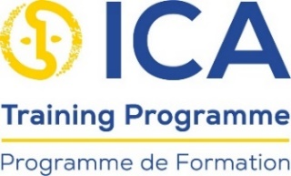

[Add details of the organisation in this footnote]

