|  |  |
| --- | --- |
|  | ICA New Professionals Survey – 2016: Final Report  Abstract  This survey report presents findings on WHO New Professionals are, WHAT they do to get employed and HOW they could be better supported to keep and enjoy their employment. It ends with recommendations for the New Professionals Program and the ICA.  Under the guidance of Cécile Fabris  Submitted by:  [Gabriela ANDAUR](http://www.ica.org/en/member/11931)  [Ryan COURCHENE](http://www.ica.org/en/member/14538)  Dolores GRANT Tibaut HOUZANME  Nicola LAURENT Annelie de VILLIERS Yujue WANG  Nicola WOOD |
|  |  |

Contents

1. Introduction 2

2. Objective 2

3. Survey Methodology 2

3.1. Survey Questions Preparation 3

3.2. Survey Administration 3

3.3. Results validation 3

4. Results Analysis 3

4.1. Demographics 4

Age Groups 4

Respondents’ Affiliation per ICA-defined Regions 4

Levels of Professional Education 5

4.2. Employment 6

Diverse Job Titles Held by NPs Surveyed (from responses in English) 6

Length of Time from Graduation to First Employment 7

What is Critical to Achieving Employment 8

Job Satisfaction 8

4.3. Career & Career Development 11

Training and Training Needs 11

Mentorship 13

Advocacy for the Profession: Select Qualitative Comments 14

Professional Network 15

5. Conclusion 17

5.1. Actions to be Completed by the NP Programme 18

5.2. Recommendations for ICA 26

6. Credit, Versions Authority and Disclaimer 26

7. Annex 1 - Survey Questions (See Attached) 26

8. Annex 2 – Survey Responses (See Attached) 26

**ICA New Professionals Survey – 2016**

**Final Report**

# Introduction

This report outlines the findings of the New Professionals Survey, which was available online from 18 July- Friday 12 August 2016. It was created by members of the ICA’s New Professional Program (NPP) under the guidance of Cécile Fabris, the Coordinator of NPP.

The survey’s preliminary results were presented at the 2016 ICA Congress, to an interested audience that engaged with the topics covered, asking questions and making recommendations. These suggestions have helped shape the organization and presentation of the topics the survey dealt with.

Though the results have been grouped by main topics, the survey data is attached as Annex 2.

The NP hopes these results will be useful for the ICA’s future planning in relation to New Professionals, with the report highlighting the WHO, WHAT and HOW of New Professionals.

# Objective

The objective of the survey was to get to know and understand the global body of New Professionals (NPs), particularly their:

* Experiences starting in the Archives/Records Management profession
* Job satisfaction
* Training and development needs
* Knowledge and expectation of global and national professional associations
* Any other help they needed or concerns they may have.

# Survey Methodology

Our approach consisted of four steps; survey preparation, administration, results validation, followed by the analysis.

## Survey Questions Preparation

Based on the objectives, we brainstormed and selected specific questions we wanted to have the answer to. This iterative process led to some revisions and some consolidation of questions that appeared as duplicates. It also led us to remove and or readapt some questions that did not necessarily fit with different regions and languages.

## Survey Administration

The process consisted of finding a survey tool that could reach our audience, making our job easier and allowing efficient access to the results and enabling easier analysis.

Due to our experiences and abilities, we settled on [Google Forms](https://www.google.com/forms/about/), a survey tool from Google that offers an online collaboration platform.

Once the questions had been finalized and the English version of the survey completed, we proceeded to translate the survey into Chinese, French and Spanish. In total, the survey was presented to the public in four languages. This step was challenging as some of the library, information and archival science practices and terminologies are different depending upon the language and region.

With the four versions ready, the survey was distributed on social media, by email, on listservs, and on the ICA’s website from July 18, 2016 to August 12, 2016 inclusive. The timeline coincided with vacation in many areas, and did not allow for much promotion time, and this is likely to have impacted the response rate.

## Results validation

In total, 39 questions and data collection points were included in the NPs survey. Due to some issues in examining answers related to the various education systems and practical environments, some of the answer responses were considered invalid. Different interpretations of these questions led to different understandings from the NPs answering, and sometimes the questions were not well suited to the realities of the respondents. In the end, 37 questions/points and responses were considered as valid in the main English version used.

# Results Analysis

The surveys were circulated on Facebook, Twitter, blog posts, Listservs, LinkedIn, WhatsApp, in newsletters and direct emails to universities & professional associations.  845 responses were included (851 received), with 399 in English, 221 in Spanish, 130 in French, and 102 in Chinese.

The purpose of the results analysis was to use the findings to enhance the work of the New Professional Program and network and to assist the ICA going forward, and to particularly help target activities that will generate and encourage more interaction between the ICA and NPs.

Following is a detailed analysis of the responses collected from the surveys:

## Demographics

The demographics questions tend to address the question of Who the NPs are; the age groups of NPs, their regional affiliation and level of education.

### Age Groups

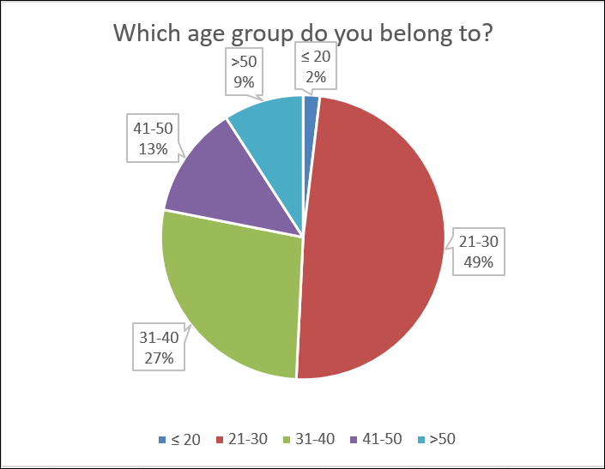

Takeaway:

•The ages of most of our respondents were between 21-30 (49%).

•More people over 50 (9%) than people under 20 (2%) identified as a new professional.

### Respondents’ Affiliation per ICA-defined Regions

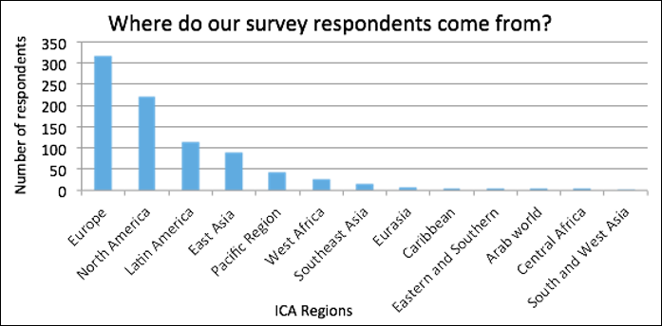

Takeaway:

• Europe and North America represented up 63% of the respondents to the survey.

•The Arab, Caribbean, Central Africa, Eastern and Southern Africa, Eurasia and South and West Asia ICA Regions were under-represented with each having less than 1% of respondents. Some of the reasons may include that the best forms of communication to reach NPs in those regions were not identified prior to the survey distribution. The survey period (July 18 to August 12) coincided with summer vacation in many regions, and the deadline to complete the survey was very short. There is also the possibility that the digital divide may have impacted some regions more than others. Finally, the regions with more respondents map to the regions the current NPP members come from.

### Levels of Professional Education

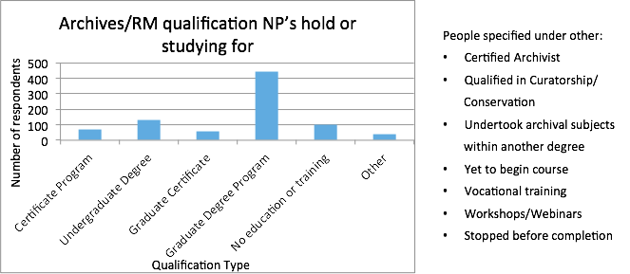

Takeaway:

•A high percentage of respondents have completed or are completing studies of varying levels in archives/records management, with 51% completing a graduate degree program.

•Many of the respondents, who selected ‘other’, did so to specify that they had undertaken subjects in archives and records management but it was not the name of their degree.

•To the question ‘*Was an archives or records management qualification a requirement for your current position?*’, approximately half of the respondents (51%) stated that a degree in archives or records management was a requirement for their current job. A third of the participants (29%) responded that this was not a requirement. The remaining 20% selected ‘other’ to say that relevant experience or interest in the profession was required with several also noting that whilst a professional qualification had been mentioned as desirable, it was not essential.

## Employment

The employment topic groups together and investigates What NPs do, what it takes to find employment and whether they are satisfied in their role.

### Diverse Job Titles Held by NPs Surveyed (from responses in English)

These positions were referenced by the NPs surveyed:

User Applications Liaison, University Records Manager, Transforming Archives Trainee, Systems Manager, Special Collections Assistant, Senior Archivist, School Archivist, Researcher & Archives Assistant, Records Program & ECM Administrator, Records Officer, Records Management Specialist, Records Management Officer, Records Assistant (Systems Administration), Records Administrator, Records & Information Management Technician, Province Archivist, Program Analyst, Processing & Special Collections Librarian, Processing Archivist, Policy Research Assistant, Photograph Archivist, Outreach Archivist, IT Coordinator, Information Governance Officer, Heritage Programs & Services Coordinator, Heritage Officer, Government Records Assistant, Electronic Records Archivist, Document Management Specialist, Director, Library & Archives, Director of Archives, Digital Special Collections Librarian, Digital Projects Graduate Assistant, Digital Curation Officer, Digital Archives Officer, Digital Archives Assistant, Corporate Librarian/Archivist, Content Management & Archives Librarian, Consultant, Collections Manager, City Archivist, Associate Curator of Special Collections, Archivist/Librarian, Archivist/Assistant Curator, Archivist & Project Coordinator, Archivist & Assistant Records Manager, Archives Advisor, Archives Specialist, Archives & Records Officer, Archive/Library Assistant, Digital Archivist, Project Archivist, Archival Intern, Archivist, Archival Assistant, Privacy Officer.

Takeaway: Titles and positions are very diverse. Job searches should be expanded to include these titles so that NPs don’t miss available opportunities.

### Length of Time from Graduation to First Employment

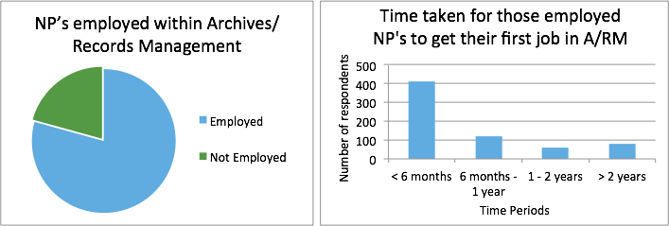

Takeaway:

•Only 8% of respondents declared they were seeking employment, with 68% already employed and a further 14% studying and working.

• The total of those employed and/or studying and working at the same time is 693. Of that number, 670 respondents stated they were employed within records and archives. Of the overall respondents 79% were employed in the sector, those currently seeking employment or studying would account for that difference.

• It is encouraging to see that 79% of those who are working within the sector were employed in their first job within a year. However, for a relatively high percentage (12%), it took over two years and this appears to be a global trend.

•56% of respondents gained their first job because of contacts in the area. They were either known to the organisation, a colleague, lecturer or a friend informed them of the opportunity or they utilised a professional association or mailing list or list-serv.

### What is Critical to Achieving Employment

The following qualitative comments will help further understand the quantitative data gathered on the employment topic:

***“… it sometimes feels like I am supposed to know everything or be extremely experienced after only qualifying last year.”***

***“Everyone wants you to have the skills and do the work of a programmer, while getting paid the salary of an administrative assistant.”***

Overall, of 670 respondents, these factors were important in gaining employment:

* Previous job experience
* Level of education
* Technical skills
* Interpersonal skills
* References
* Being recommended for the position by peers/colleagues/educators

Takeaway:

* From a global perspective, participants felt the most important factors in helping them find employment was their level of education (60% finding this very important) and their previous job experience (54% finding this very important).
* Technical skills and interpersonal skills were also viewed as very important whilst references and recommendations were viewed as having less importance.
* It would have been interesting to let participants reply by ranking each factor from most to least important. However, that was a limitation of using Google Forms.
* The NP Programme could support the enhancement of technical skills and interpersonal skills through the promotion of relevant training, networking events and providing opportunities for interaction with other professionals.

### Job Satisfaction

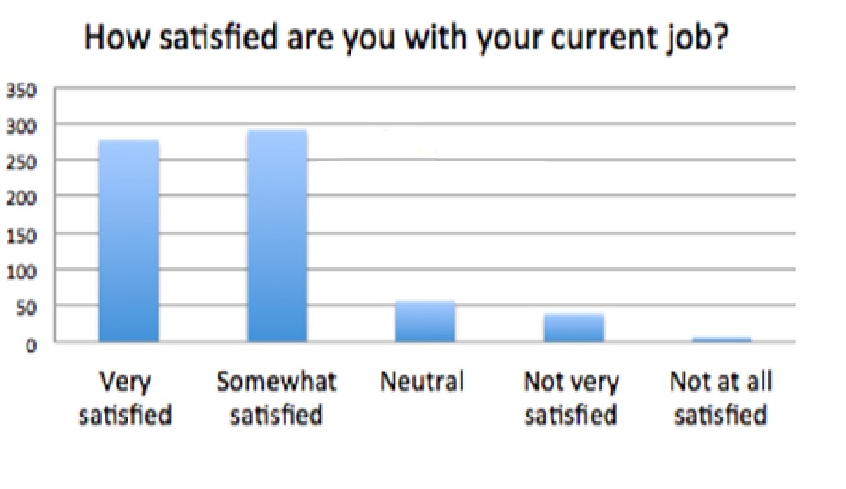  
Takeaway:

Almost half of the respondents answered that they are very satisfied with their employment.

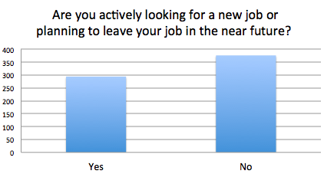

Takeaway:

Despite high levels of satisfaction, close to half of NPs are looking for another job or planning to leave their current job. To gain a clearer understanding of the reasons why satisfied NPs would leave their job, a follow-up question was included, see below.

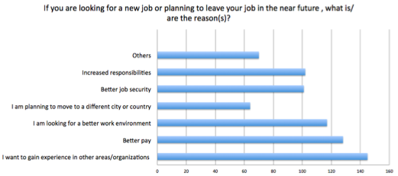

Takeaway:

The reasons varied significantly as to why people might be looking for new jobs, but imply that while many people are satisfied with the work they are currently doing, they are often looking to expand their skill set, earn a higher salary or require better job security or work environment. It suggests that whilst NPs enjoy the work they do they are often looking for the next step in their professional career.

This was a multiple-choice question; so people were able to respond with as many reasons relevant to them. The same applies to the question below:

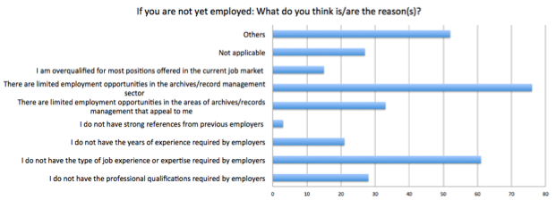

Takeaway:

While the lack of job opportunities in archives and records management is the number one reason, the experience requirements of job seekers is also a critical deterrent to NPs getting a job.

## Career & Career Development

This topic highlights How NPs keep their employment, and the various means of training, coaching, and career planning they are involved in.

### Training and Training Needs

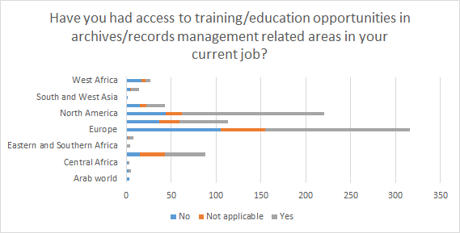

Takeaway:

Whilst ongoing training opportunities appear more available in North America and Europe, it is crucially lacking in all African, South Asian and Arab world regions. It is important to note that this data could be skewed due to the low level of responses received from these areas.

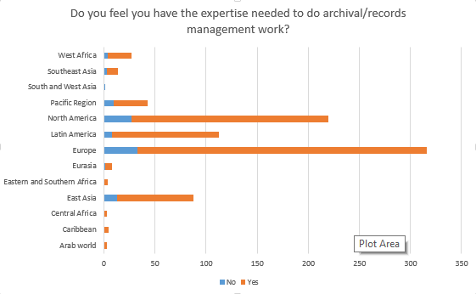

Takeaway: The regions with NPs who felt they had the required expertise to do archival work are:

#1 Europe

#2 North America

#3 Latin America

#4 East Asia

#5 Pacific Region

#6 West Africa

The rest of the regions do not have significant data.

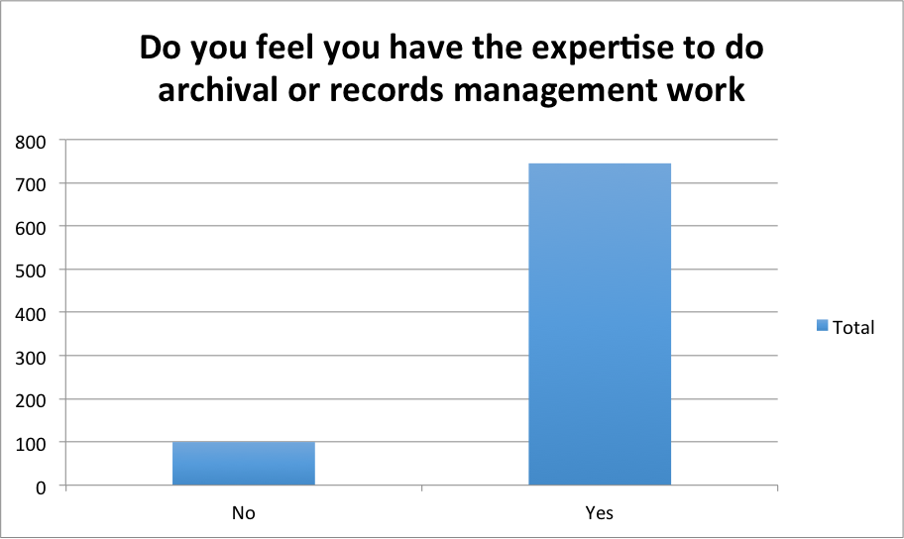

Takeaway: Globally, NPs have expressed confidence that they can complete archival work, if given a chance.

### Mentorship

The need for mentorship has been demonstrated both quantitatively (below) and qualitatively through comments such as: ***“There is so much to learn I don't know where to focus my energy!”***

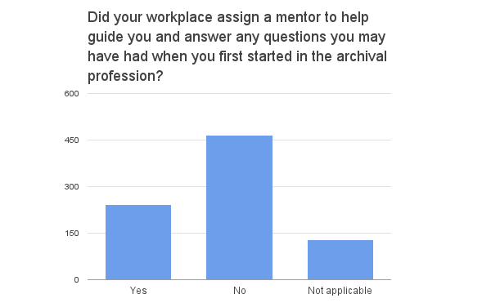

Takeaway: Only a quarter of respondents have been assigned a mentor, while half do not have one. It is logical to assume that mentors would help with or help mitigate many of the employment issues NPs are presented with in the work environment.

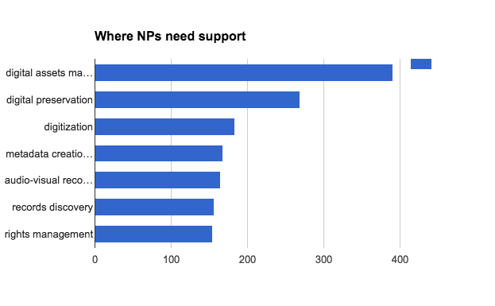

***Qualitative comment: “An area where training would be appreciated is in establishing how to maintain archival standards while in difficult environments. Be they financial, staff shortage, equipment problems. What needs priority in these situations and are there more affordable options available.”***

Takeaway:

There was a very strong indication that participants felt the need for more training/support in the area of digital records. Digital assets management was the area most frequently selected option (46%), followed by digital preservation (22%) and metadata creation (20%). Audio-visual records was the next most popular area selected for further training (19%), closely followed by records discovery (18%) and records management (18%).

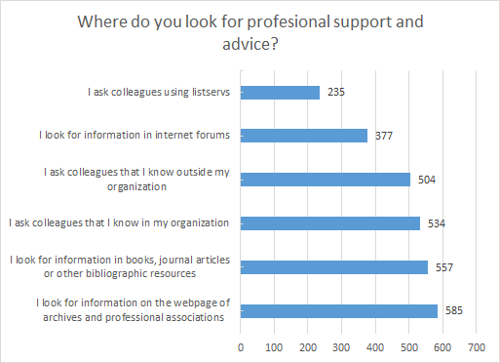

Takeaway: In the absence of mentorship opportunities or a guide, NPs use resources in the following order to look for support and advice:

#1 Professional associations

#2 Journal and other bibliographic references

#3 Colleagues in organization

#4 Colleague outside organization

#5 Internet forums

#6 Listservs.

### Advocacy for the Profession: Select Qualitative Comments

***“Support from governments is non-existent, how can we change that?”***

***“Unfortunately, I believe this work is undervalued and businesses are not aware of the benefits that records management can bring to them. It is necessary to gain more recognition and I believe ICA should play a greater role in its dissemination and strengthening”***

***“People in charge of archival matters should be archives professionals… if not, then things are like they are now… right?”***

Takeaway: The comments speak for themselves.

### Professional Network

Overall, the questions relate to membership of professional associations more generally with particular questions related to membership, awareness of, and interactions with the ICA and its programmes.

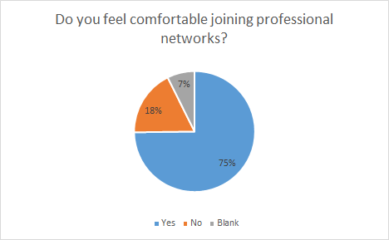

Takeaway: About 75% of NPs feel comfortable joining professional associations or networks. This seems like an opportunity not yet exploited.

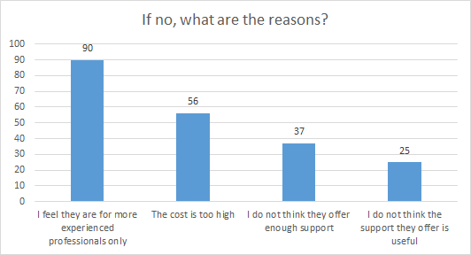

Takeaway: Out of the 18% of NPs who responded with no, these outcomes signal a potential feeling of a lack of relevancy of professional organizations (including the ICA) to NPs’ profiles, needs, and aspirations.

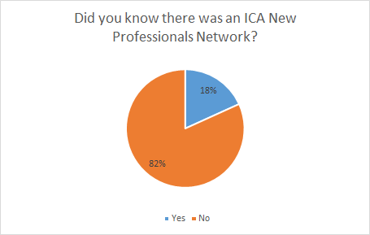

Takeaway: The NPs surveyed were generally not aware of the ICA’s NP network. This is possible due to it only operating through Facebook at the time of this survey. Therefore, more needs to be done around the promotion and advocacy of the network, and expanding the network to ensure it reaches more than those using Facebook.

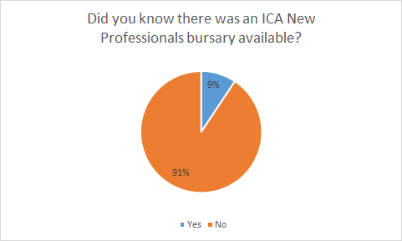

Takeaway: The ICA New Professional Program and the bursary need to have increased advertisement and promotion in future years. The survey reached more people than the network did at the same time and this is likely due to the wider set of distribution tools used. However, there were also limitations to this reach, largely linked to the regions the 2016-2017 NPP members reside in.

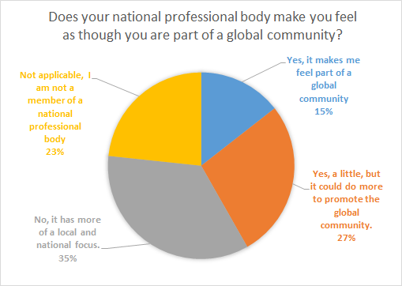

Takeaway: Only 15% of the NPs surveyed feel that their national professional body makes them feel really part of a global community of professionals, meaning an untapped potential exist to improve relationships between the ICA and national professional associations.

## Conclusion

The purpose of the survey was to see trends, discrepancies, and areas of opportunities that could be addressed by the ICA.

From a methodological point of view, some issues emerged and demonstrated the challenges of reaching a global community and using a single instrument to survey a group of professionals with heterogeneous characteristics and different regional, cultural and professional backgrounds.

Although many efforts were made to disseminate the survey as widely as possible, the results are more significant in terms of sample for North America and Europe. The regional distribution of survey respondents is uneven, very likely due to the limited access to regional networks and communications channels outside the spectrum of the NP team. Slight differences or emphases could be noticed when analysing some of the responses separately by region. However, the small size of some regional samples did not allow us to reach conclusive results.

Despite these limitations , the survey results are indicative of a few noteworthy topics:

1. This survey received a more enthusiastic response than we expected, suggesting that there is a large audience of NPs requiring support and guidance that the ICA may help to provide and who are potentially likely to join the ICA as members if more work is actively done to encourage their participation.
2. Unemployment and stability of employment for NPs is a problem
3. Our survey indicated both an interest in joining and a significant lack of awareness of the ICA NPP
4. A significant proportion of NPs identified that they felt uncomfortable joining professional networks in general
5. NPs want better education and guidance particularly related to digital skills, on-the-job training, and mentorship

## Actions to be Completed by the NP Programme

**What has been done so far**

This survey finding have been presented and input from the ICA members considered. Following are specific actions that have been carried out since:

* NP Programme promotion  
  Significant work was put into promoting the programme when this year’s applications were launched on the 5th of December. The initial Facebook post that promoted the opening of the 2017-2018 programme reached 4,626 people. Nine tweets to promote the new programme were posted on the NP Twitter account between December and February 2, of which were in Spanish. These tweets reached a total of 10,822 people, averaging 1202 people per tweet. The NP Program was promoted on several listservs through the sharing our newsletters, the promotion of the bursary for 2017, and the requests for contributions to future newsletters and translation.
* NP Network growth

Since taking over the Facebook page on 1st August, 2016 the number of followers has grown from 569 to 908 (as of 31 March, 2017), a gain of 339 followers. This means the NP Facebook network has grown almost 60% in 9 months. Also, the newsletter subscribers has grown from 184 to 239 (as of 30 March 2017), a gain of 55 followers. This means the NP Newsletter network has grown 30% in 7 months. The NP Twitter account was set up for the first time in September 2016. The account has gained 321 followers (as of 18 April 2017).  We have gained followers every month since creating the account.

* Social Media campaign

Facebook has continued to be a popular method of connecting with New Professionals with the number of followers increasing more rapidly than ever in the last 9 months. On average we post 5 times a week, generally from Monday to Friday. Posts are published at different times of the day to ensure they reach everyone. Our post reach (how many people see a post) averages out to be 460 viewers a day. Twitter has also proved to be a very worthwhile social network, having gained a considerable number of followers which has increased every month. The NP Twitter account works in harmony with the ICA Twitter account, to ensure maximum engagement and brand consistency. Tweets focus mainly on archives news relevant to new professionals, announce new issues of the NP newsletter; new content on the NP Facebook; ICA announcements; links to relevant publications; archives events and general activities in the professional archives sphere, as outlined in the Twitter policy and strategy. The survey has enabled us to better meet the needs of New Professionals via social media and ensure that we are posting items at regular intervals that match the themes and topics based on the responses of the survey, including job or scholarship opportunities. Through the Facebook page, we also launched a campaign to get New Professionals to join a team of translators who can translate posts for the ICA NP Facebook page (see below translation section).

* Newsletter

Since the Congress in Seoul, there has been the newsletter has been issued once every two months. Each newsletter is themed around a particular topic based on the most frequent responses given in the survey. Newsletters have been made available in both English (with some French) and Spanish. The English versions are sent to our subscriber list and made available through a weblink, whilst the Spanish newsletters are currently only made available through a weblink.

The newsletter weblinks are shared on ICA NP website, various Facebook groups including the ICA NP Facebook, ICA NP Twitter, and ICA and UK email listservs. Calls for contributions from new professionals for the next newsletter are shared through the ICA NP website, various Facebook groups including the ICA NP Facebook, ICA NP Twitter, and ICA and UK email listservs. Following are some statistics on the Newsletters:

Newsletter Subscriber Statistics:

|  |  |  |  |  |  |  |
| --- | --- | --- | --- | --- | --- | --- |
|  | On 10th November 2016 (first newsletter sent) | As of 19th December 2016 (first newsletter report) | 23rd January 2017 (second newsletter sent) | As of 13th February (second newsletter report) | 27th March 2017 (third newsletter sent) | As of 30th March 2017 |
| Number of subscribers | 184 | 196 | 213 | 231 | 235 | 239 |
| Number of opens | n/a | 26.1% (48) | n/a | 29.9% (63) | n/a | 28.6% (67) |
| Number of clicks (on hyperlinks in newsletter) | n/a | 3.8% (7) | n/a | 10.4% (22) | n/a | 6.4 (15) |

Newsletter Access Statistics (URL weblink - number of clicks to date):

|  |  |  |  |  |  |  |
| --- | --- | --- | --- | --- | --- | --- |
|  | 10th November 2016 newsletter ENG | 10th November 2016 newsletter SPA | 23rd January 2017 newsletter ENG | 23rd January 2017 newsletter  SPA | 27th March 2017 newsletter ENG | 27th March 2017 newsletter SPA |
| Number of URL clicks to date: 30/03/17 | 458 | 367 | 814 | 481 | 500 | 71 |

* Chinese Social Media campaign

The Official Accounts for the Chinese Social Media campaigns on WeChat, released the first article in July 26, 2016. Until now (March31, 2017）, 41 articles have been published in total, and there are 851 fans as shown in the green section of the graph below.

.

Number of Chinese Social Media Fans

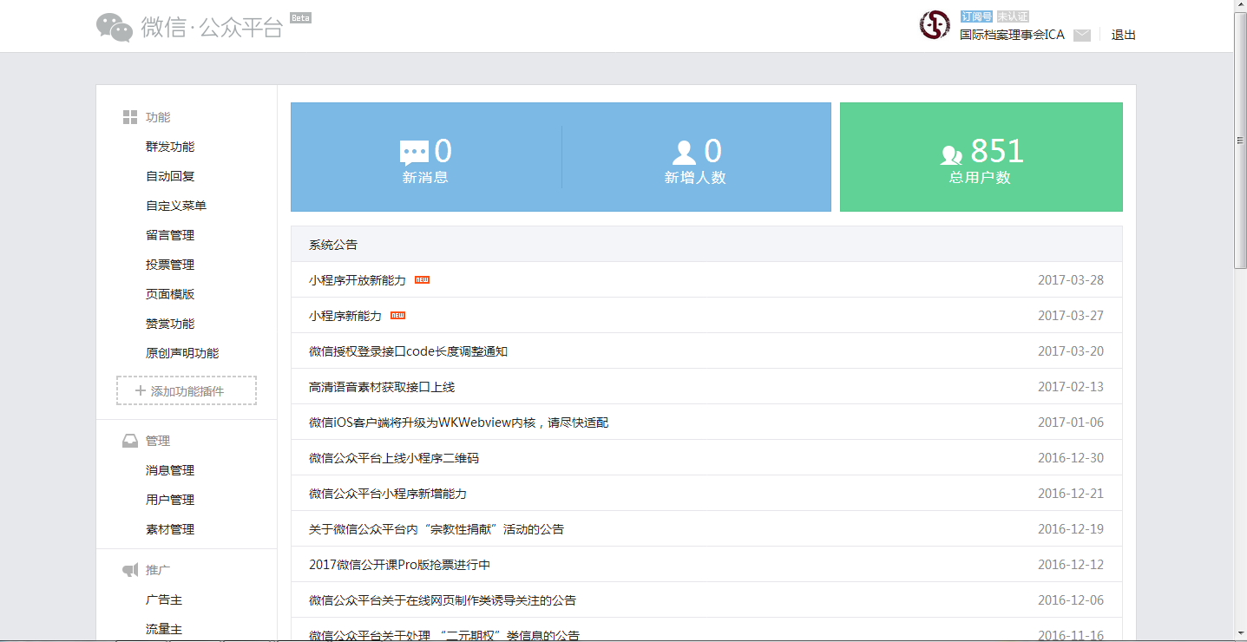

The development of the Official Accounts on WeChat is gratifying and below are some statistics:



Report on WeChat Content Published: 2016.07--2016.10



Report on WeChat Content Published: 2016.10--2016.12



Figure 1: Report on WeChat Content Published: 2017.1--2016.3

After discussion in 2017, we decided to publish the message once or twice a week and the main contents include some archive knowledge and related news. We also decided to introduce some famous archive professionals and their contributions in archive all over the world.

* Translation

The launch of an ICA NP group of translators for Facebook posts was successful with 6 people responding to our post and offering to translate into 8 languages (Chinese, Romanian, German, Finnish, French, Polish, Thai and Indonesian). And on average, they are happy to translate one (short) post a week. We have since asked them to translate two posts - the calls for contributions for the newsletter - but will begin to use them more regularly going forward.

Utilizing the language skills of the current NPP members has enabled the newsletter, calls for contribution, and Facebook posts to be translated into both English and Spanish, from submissions in English, Spanish and French. It is hoped this will encourage a wider response.

* ICA NP website

The ICA website has a section dedicated for the New Professionals Program. The site still being developed but currently provides information on the listing of executive members of the program. It also provides the latest news on anything the ICA NP Program is involved in, or wants to promote. It also provides access to current and previous editions to the NP Newsletter as well as links to the NP Social media outlets on Facebook and Twitter. There is also a link to apply for a student membership of the ICA on the website as well. At the beginning of the year, the website listed a call for applications for the NP bursary for the 2017 year. As the site develops, it will provide a list of all previous NP executive members and provide a list of free archival on-line learning resources. Suggestions and approved contributions to the website are welcomed.

**What needs to be done or continued**

1. Map the survey results to regional membership numbers
2. Promote the New Professional Programme and the ICA by extension
3. Increase NP network
4. Encourage those outside the program to engage more with the NP network by contributing to creating content for the newsletter, Facebook page, Twitter and website.
5. Target more NPs on different social media platforms and with newsletter content
6. Create the newsletter content in multiple languages
7. Reach out to NPs on Chinese social media
8. Encourage NPs to get involved in various projects including translation - Spanish and Arabic particularly
9. Inspire NPs to gain membership of the ICA, and involve them in the ICA to create a reciprocal beneficial relationship to build their CVs

## Recommendations for ICA

The following actions would be helpful from the ICA:

1. Create a mentorship program, preferably online, where mentors and mentees can be matched per specific areas of interest
2. Create a guideline document for mentor/mentee relationships (even if the ICA doesn’t establish its own program)
3. Set up a forum or way that NPs can ask experienced NPs, or ICA professional’s questions that they are afraid to ask their employers or fellow archivists
4. Allow employers or fellow archivists to provide input or answer questions they may have about the New Professional Programme
5. Carry out, or support others carrying out, surveys on a regular basis to better understand the needs and situations of new professionals. The collaboration of regional branches and sections in survey dissemination could help achieve higher and more representative responses from all ICA regions. The results could also provide information about areas that need to be developed at a regional and/or global level and provide insight into the ways the ICA can improve engagement with new professionals.
6. Make recommendations to the ICA Training Officer, to regional branches/expert groups in terms of training content tailored to NPs interest to inspire involvement
7. Promote the ICA NPP and its network at all opportunities.

## Credit, Versions Authority and Disclaimer

This survey report has been prepared by all the New Professionals grantees of 2016. It used the presentations the group prepared and presented at ICA Seoul and may have been translated into French, though this English version remains authoritative. Though Tibaut Houzanme played a lead role for the compilation and presentation of the contributions from all the team, with Cecile’s guidance, the content of this report does not engage any of the responsibilities of the organizations any of the authors work for. It reflects their individual opinions and assessments.

## Annex 1 - Survey Questions (See Attached)

## Annex 2 – Survey Responses (See Attached)